**Simple throw dice test**

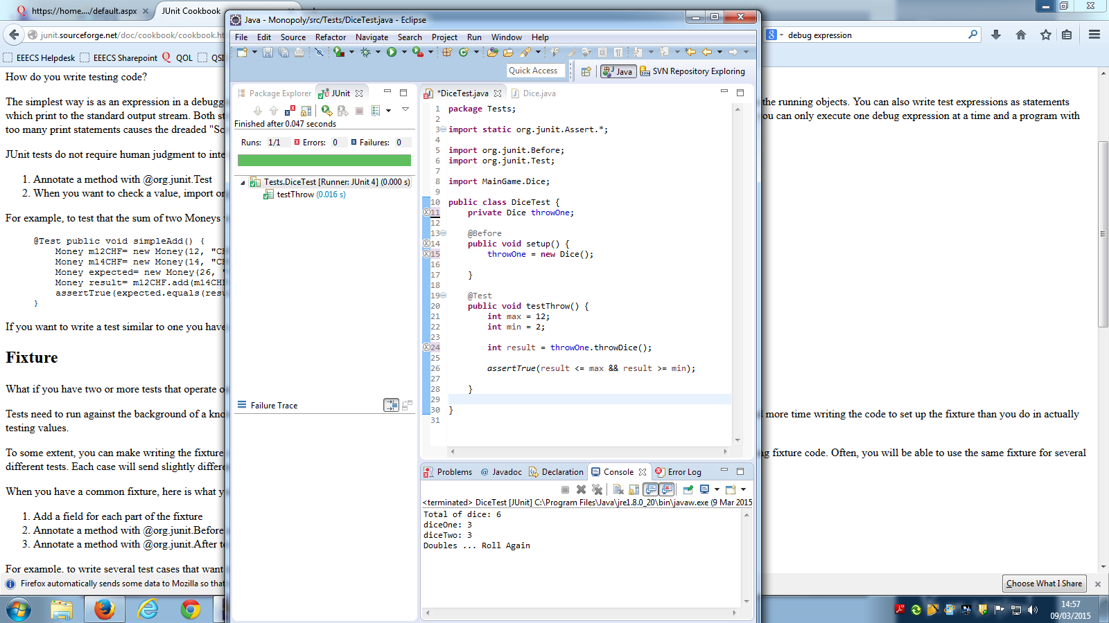

**Result**

The setup method creates a new dice object that we will be using in multiple tests.

Method testThrow creates two integers, the maximum and minimum of an expected throw. It tests the result of throwing the dice to ensure it is within the range.